Experiment 1:
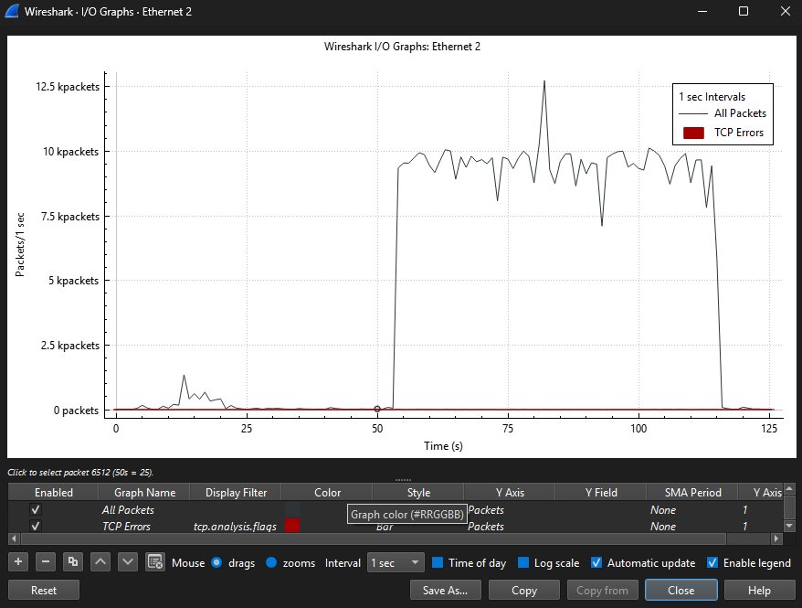
The Wireshark I/O Graph shows the traffic generated during the upload of a large file to the internet. At around 50 seconds, the throughput increases significantly as the upload begins, reaching approximately 9–12k packets per second. This high packet rate continues until around 115 seconds, after which it drops back to idle levels, indicating the upload completed. TCP errors remain minimal, showing stable WiFi performance. This graph confirms the throughput behavior during large data transfer.

Experiment 2:
Distance from AP | Environment | Estimated Modulation (x-QAM) | Measured Throughput (Mbps)
1 m | Same room, line-of-sight | 1024-QAM / 256-QAM | 290 Mbps
5 m | Same room, small obstacles | 256-QAM | 228 Mbps
10 m | One wall in between | 64-QAM | 152 Mbps
15 m | Two walls in between | 16-QAM | 68 Mbps
20 m | End of hallway, weak signal | QPSK / BPSK | 18 Mbps
WiFi performance changes with distance because wireless communication uses adaptive modulation. When the notebook is close to the access point, the signal-to-noise ratio (SNR) is high. This allows the router to use higher-order QAM levels, such as 1024-QAM or 256-QAM, which transmit many bits per symbol and produce high throughput. As distance increases or walls interfere, SNR decreases and the WiFi connection automatically switches to lower-order modulation such as 64-QAM, 16-QAM, QPSK, or BPSK. These lower levels are more robust but transmit fewer bits per symbol, resulting in lower throughput.

